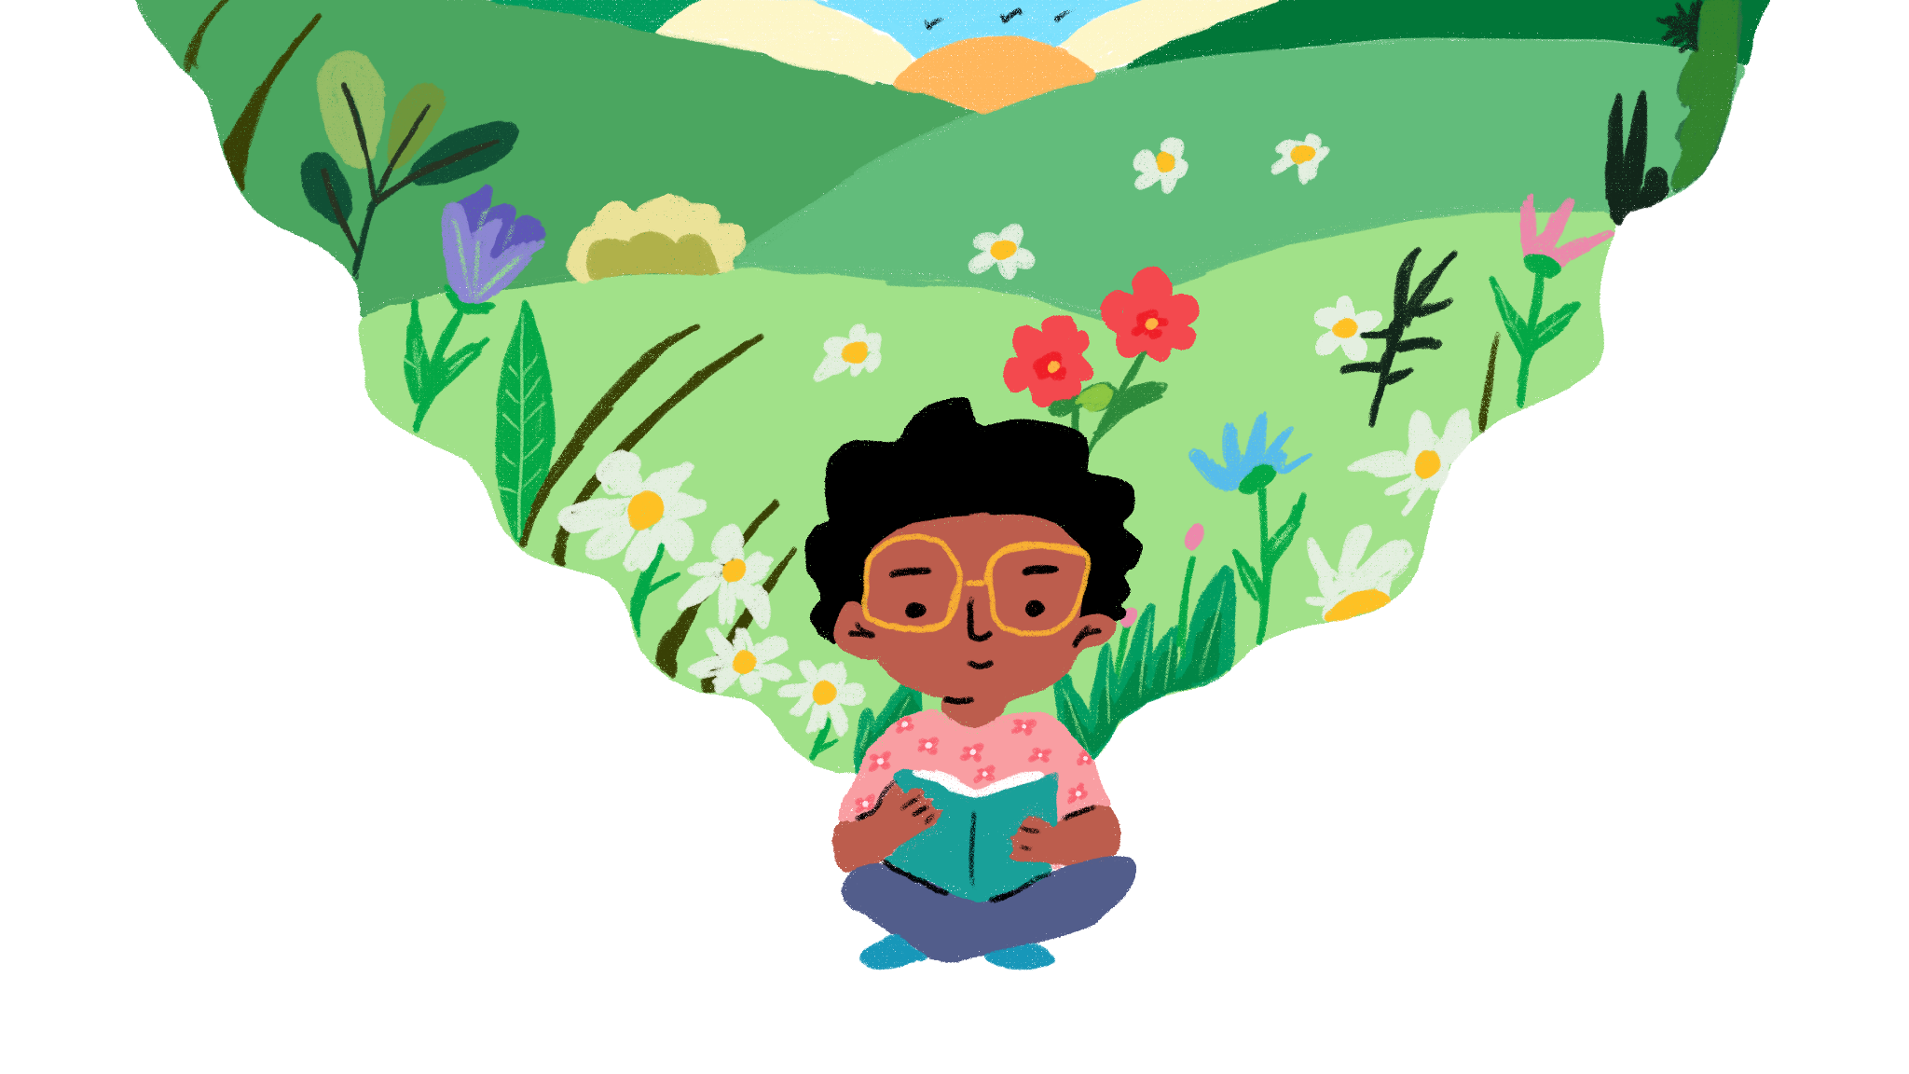

Save our planet, Save our future

General Comment No. 26

Children’s Second Consultation Toolkit

15 November 2022 - 15 February 2023

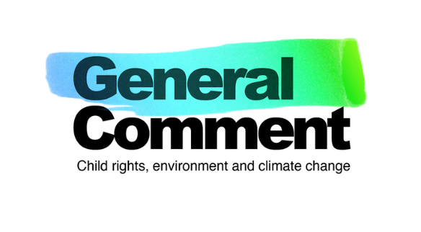

Contents

Welcome from the Children’s Advisory Team 3
Introduction 4
What has been happening so far? 4
What’s next? 5
How can children get involved in the second round of consultations? 5
What will happen to the findings from the consultations? 6
Host a workshop 7
Before the workshop 8
A note on eco-anxiety 8
During the workshop 9
After the workshop 9
Consultation Activities 11
Activity 1 12
Activity 2 13
Activity 3 14
Contact 16
Annex 17
TEMPLATE A: Information Sheet and Consent Form 17
TEMPLATE B: Recording Templates 19
TEMPLATE C: Activity 3: Postcard 22

Welcome from the Children’s Advisory Team

Our message to children worldwide:

Hello, Hola, Olá, Mālo, Muraho, Allu, tungjatjeta, xin chào, Moni Moni onse, Namaskar, Lozi

We are members of the Children’s Advisory Team. We are from 13 different countries and are aged between 11 and 17-years-old. We are working with the United Nations Committee on the Rights of the Child to make sure they hear from children as they develop important guidance for countries all over the world about children ’s rights and the environment, with a special focus on climate change. This guidance is known as General Comment No. 26.

Historically, children from various parts of the planet have been excluded from spaces of power and decision-making. In many moments, our voices have not been heard and have not had an echo. But that is changing. Children are rising up to face the great challenges of our generation. We know that we don’t have much time with the environmental crisis and that we all must take action NOW!

That is why we, the Children’s Advisory Team, are inviting you to join us in sharing your views and ideas for General Comment No. 26, a process where our voices - the voice that we have always had but adults did not want to hear - can be made visible. You all matter. General Comment No. 26 is meant for us, all children .

There is still a chance to save our planet, to save our future. We are fighting climate change for a healthier life and the victory of this fight will be impossible without your help. We invite all to express your views and opinions about actions that address climate change and protect your environment by participating in our questionnaire or taking part in a workshop. Join us in protecting our rights today and in the future.

Thank you!

Āniva, Angella, Bach, Elisabeth, Esmeralda, Francisco, George, Kartik, Madhvi, Maya-Natuk, Olt, Sagarika and Tânia

Follow our team updates on social media:

Twitter: @GC26_CAT
Instagram: @GC26_CAT
Facebook: GC26_CAT

A message to adults: your support is key!

Thank you for your interest in supporting children’s participation in the General Comment No. 26 consultations and for your commitment to protecting and promoting children’s environmental rights. We look forward to hearing from the children you are supporting!

Introduction

The environmental crisis is a child rights crisis. Children are being forced to leave their homes, missing out on school, and losing their lives. They are speaking up demanding action from governments. From marches and protests, taking action online, tree planting, using art and more.

The United Nations is listening to the calls of children.
The Committee on the Rights of the Child is building guidelines for countries to protect children’s rights affected by environmental harm. This guidance is known as General Comment No. 26. It will hold governments accountable when they violate children’s rights and strengthen environmental action.
Children worldwide are invited to help shape General Comment No. 26 through workshops on different topics - like climate change, environmental education and more - online questionnaires and discussions with people in their region.
Their views are important to creating General Comment No. 26. They have a right to have a say in decisions about matters affecting them, they offer unique insights into how environmental harm and climate change impacts children, and they have lots of creative ideas and solutions!

Article 1 of the United Nations Convention on the Rights of the Child (UNCRC) explains that a child is any person under the age of 18. We also use ‘young people’ in our work as we know older children often define themselves in this way. So, if you are under the age of 18, the Committee wants to hear from you!

You can find out more about General Comment No. 26 at: childrightsenvironment.org

What has been happening so far?
2022
- February: The Children’s Advisory Team was created with 13 children aged 11-17 from all over the world. They are helping to design the consultations so the Committee can hear from other children worldwide.
- March: The first round of consultations began, including the launch of an online questionnaire for children to share their experiences and challenges on their rights, the environment and climate change.
- March - June: 7,416 children from 103 countries participated in the questionnaire.
- August: The findings from the questionnaire were shared with the Committee to help them create the first draft of General Comment No. 26. Take a look at the findings from the questionnaire at childrightsenvironment.org/reports
- September - October: The first draft of General Comment No. 26 was completed. See a child-friendly summary here: bit.ly/childfriendlydraft

What’s next?
2023
- 15 November 2022 - 15 February: The second round of consultations will take place. The Committee wants to hear from children across the word. Find out more in this toolkit!
- April: The findings from the consultations will be shared with the Committee to help them create the final General Comment No. 26.
- June: The final General Comment No. 26 and a child-friendly version will be launched, alongside a Global Charter reflecting children’s views on their environmental rights.
- June - beyond: Children, young people and allies use General Comment No. 26 as a tool to make sure governments respect and protect children’s environmental rights!

How can children and young people get involved in the second round of consultations?
Consultations will take place from 15 November 2022 until 15 February 2023. There are two ways for children and young people to get involved, described below.

1 Complete an online questionnaire
This questionnaire includes questions provided by the Committee and an opportunity for children to submit additional evidence to inform the final General Comment No. 26.

For the questionnaire, please head over to: https://l4cqlef9g5g.typeform.com/children

2 Host or take part in a workshop
This toolkit gives information and tips on how to host a workshop for children. It features the same questions in the online questionnaire but presented as activities.

This toolkit is available in other languages which you can find at childrightsenvironment.org/children-and-young-people

The Committee is delighted to be working with Climate Cardinals, an international youth-led organisation working to make the climate movement more accessible to those who do not speak English. They have over 6,000 volunteers translating climate information into over 100 languages - some of whom have supported us to translate this toolkit. If you would like the toolkit in a language that is not available please contact us at: team@childrightsenvironment.org.

If you are over 18, please see here for how you can share your views: childrightsenvironment.org/global-community

What will happen to the findings from the consultations?

1 General Comment No. 26
The findings will help the Committee to revise the first draft of General Comment No. 26, to make sure the final version reflects children’s views, experiences and ideas as best as possible.

2 Global Charter
The findings will also be used to create a Global Charter, an inspirational message from children around the world on their vision for a safe, healthy and sustainable world that respects their rights. This will be made up of children’s own words and artwork and be launched alongside General Comment No. 26 to raise awareness of why it is so important for children.

Host a workshop

The General Comment No. 26 consultations are a global effort and it is important that any child or young person can take part, if they wish to.

Children express themselves in many ways and have different needs and access to materials and support. This toolkit has been designed to support children to take part in a way that works best for them.

It is important that participating children are safe and well at all times. The Committee on the Rights of the Child has explained the nine basic requirements for children’s participation in General Comment No. 12 (2009) on children’s rights to be heard:
- Transparent and informative
- Voluntary
- Respectful
- Relevant
- Child-friendly
- Inclusive
- Supported by training for adults
- Safe and sensitive to risk
- Accountable
To help guide you, the Children’s Advisory Team offer some top tips for hosting your workshop:
- “Give as much space and responsibilities as possible to the children. Adults should lead the workshop, but stay behind. Let the space be for children and let it flow. Give space and time for children to talk and have a conversation.” Maya-Natuk, age 17, Greenland
- “These activities have no need for a lot of materials so you can adapt the activities to be inclusive for every age, gender and background. If you have printed the toolkit, you could recycle the paper by using it for the activities.” Olt, age 15, Kosovo
- “Be open to understand the children and youth’s alternative perspectives. Have empathy!” Sagarika, age 16, UAE
- “Children must feel welcome. Be polite, clear, gentle and use simple language.” Aniva, age 16, Samoa
- “Workshops should be as creative as possible with activities (doing crafts, recycling), games and drawings as these help to keep everyone focused and stay concentrated. Make it fun!” Madhvi, age 11, USA
- “It’s important that the children know General Comment No. 26 is about them. They are the main characters. They need to know that their opinions are going to be respected.” Elisabeth, age 15, Rwanda
We have also gathered useful materials, resources and child safeguarding guides that you might like to use alongside the steps below - you can find these at here.

Before the workshop
- Make sure you have at least two facilitators - these are the children, young people or adults that will help to lead and guide the workshop. This will depend on how many children are participating but you will need at least one person to lead activities and someone to take notes and respond to any issues that may arise. If you are a child or young person hosting a workshop, reach out to a trusted adult in your school or community for their support before, during and after the workshop.
- Make sure all children have agreed to taking part. (see TEMPLATE A: Information Sheet and Consent Form). If you plan to audio record your session or take photos of children participating, you will need your own additional consent process.
- Make sure all children are safe during the workshop. Make sure a trusted adult can be the key person (the Child Safeguarder) who children can speak to if they do not feel well or safe. Introduce this person to all those participating.
- Choose a suitable time and location. This should be a quiet, undisturbed and safe space for your workshop, and at a time that works for children . Make sure to leave enough time for completing the activities. You could facilitate the activities across multiple shorter workshops - this would work well online.
- Make sure your workshop is inclusive. Consider the different factors that may impact/exclude children (particularly from more marginalised groups) from participating in your workshop - such as the workshop time, location, place, language, cost of travel. Make changes so all can participate.
- Use your creativity! You can adapt the activities so that they work for children with different needs and abilities.

A note on eco-anxiety

Many children (and adults) are feeling anxious or nervous about climate change, environmental damage and the future of the planet. The questions and activities in this toolkit have been designed to help children feel empowered, supported and eco-hopeful. Here are some things to consider to make sure children feel happy, safe and well when participating in workshops:

- Listen to and support children’s feelings
- Be honest about the realities of environmental harm and climate change and make sure information you share is accurate and from trusted sources
- Encourage children to share worries or anxiety they have with a trusted adult and support them to access professional help if needed
- Share positive, inspiring examples of environmental solutions and climate action
- Support children to take or influence action and to connect with other children who wish to do the same

“In my book ‘Pregúntale a Francisco: ¿Qué es el cambio climático’, I share the concept of ‘eco-hope’. I have defined eco-hope as a hope full of actions to defend life and take care of the planet, in the face of the crises that we are going through as a society and that threaten life such as wars, loss of biodiversity and climate change.” Francisco, age 13, Colombia

During the workshop

- Set the scene. Before beginning the activities, it is important to start by introducing children to General Comment No. 26 and why the Committee is inviting children to share their views, experiences and ideas. You can use the introduction text in this toolkit, which is taken from our child-friendly comic available at childrightsenvironment.org/comic !You can also share a child-friendly summary of the General Comment No. 26 draft: bit.ly/childfriendlydraft
- Make sure children are safe and supported. Remind children that if they feel unsafe or worried about anything during the workshop, they can talk to the trusted adult responsible for child safeguarding.
- Remind children that their participation is voluntary. Children do not have to take part if they do not want to, and can withdraw from the activities at any time. This also means they do not have to share any personal information during the workshop.
- Make time for breaks and energisers. This can be a game or simply time to get fresh air, light movement or refreshments.
- Use the recording templates. There is a template at the end of this toolkit to help you capture children’s views and ideas as fully and accurately as you can. Ask children to repeat their answers if you are not sure if you understood something they have said.
- Explain next steps. When finishing the workshop, explain what will happen next (see ‘Next Steps’ in this toolkit) and thank the children for their amazing participation!

After the workshop

1 Upload workshop findings (text and artwork) to: https://l4cqlef9g5g.typeform.com/childrentoolkit

This information is managed by terre des hommes and Child Environmental Rights Initiative (CERI) and collected on data secure platforms only for the purposes of General Comment No. 26. Please do not upload photos or images of the participating children themselves.

If you have used audio transcription, remember to delete the file.
2 Sign up to our newsletter for updates on the development of the General Comment. This is really important for receiving updates on the process and to provide feedback to children who have participated. childrightsenvironment.org/subscription

3 Spread the word. Share your support for children’s participation in General Comment No. 26 on social media. To encourage others to get involved, we invite you to share stories or news about your workshops and tag our social media channels. Please make sure you have consent to post photos.

Hashtag: #ChildRightsEnvironment

Instagram: @GC26_CAT / @tdh_de / @unitednationshumanrights

Facebook: GC26_CAT / tdh.de / unitednationshumanrights

Twitter: @GC26_CAT @CERI_Coalition / @tdh_de / @UNChildRights1

LinkedIn: terre-des-hommes-deutschland

Stay tuned! Children will be invited to share their artwork, from workshops or on their own, for the opportunity to be a part of the Save our Future, Save our Planet Digital Art Gallery! The gallery will feature selected pieces of art from children worldwide highlighting their proposed solutions to a safe, healthy and sustainable world that respects their rights. Children that are interested in participating are invited to sign up to our newsletter to be notified when the call for submissions open.

Consultation Activities

Let’s get started! There are three activities described, each designed to answer a series of questions provided by the United Nations Committee on the Rights of the Child. Children can do all the activities, or pick one or two. They do not have to answer all the questions if they do not want to.

At the end of this toolkit, you will find templates for recording the views and ideas children share in the workshop.

Key
Questions
Duration
Materials needed
Instructions

Adaptations

Activity 1

Environmental damage and climate change are impacting children across the world in very different ways. Governments have the responsibility to make sure countries do all they can to protect the environment and slow down climate change (also known as ‘mitigation’) whilst also adapting to the current and future impacts of climate change.

The Committee would like to know:

- What do you think about what your government is doing (or not doing) to protect the environment, slow down climate change, and help your country adapt to the current and future impacts of climate change?
- What kinds of things should governments and businesses think about when considering the impact their plans and decisions will have on children ’s right to enjoy a healthy environment?
- When governments or businesses do not respect their responsibilities, what do you think they should be made to do?

60 minutes

Large sheets of paper, cardboard and coloured pens/pencils.

In small groups, invite children to work together to create a map of their community or country. The map does not need to be a realistic representation, but rather an opportunity for children to reflect on what governments and businesses are doing at local and national levels in response to environmental issues and climate change.

On the inside of the map, encourage children to document - through words or drawings - the key environmental and climate challenges being experienced by children and their communities. You might like to the following questions to help guide your map-making:

- Where do children feel (un)happy and (un)safe in your community? Why?
- What are the most important issues for children related to the environment and climate change in your community/country/region?
- Do you think all children in your community are affected in the same way by these environmental issues? Who is affected more and why?

Next, encourage the children to reflect on the questions presented by the Committee and to record their ideas on the outside of the map.

After completing their maps, invite the children to share ideas with other groups and discuss the common ideas or emerging themes.

Depending on resources available, children can use natural materials such as sand, sticks or chalk. Older children might like to create 3D models, or use collage materials. If holding an online workshop, you could form breakout rooms and ask children to work together using a digital whiteboard.

Activity 2

Children have the right to access quality information and education about the environment and climate change. Children also have the right to know about their rights and how to get help or complain if their rights are not being met.

The Committee would like to know:

- What challenges do children face with finding information and learning about the environment and climate change?
- What are (or could be) the best ways for children to find information about:
- their rights
- the impact of environmental damage and climate change on their lives and communities
- government and businesses’ responsibilities to protect children’s rights to a healthy environment
- how to get help if their rights are not being respected

- What do you think children should learn in school about the environment and climate change and how should this be taught?

45-60 minutes

Large sheets of paper, cardboard, coloured pens/pencils, newspapers, magazines, scissors and glue or tape.

In pairs or small groups, invite children to create a poster using text and/or pictures which answers the questions above. You might like to encourage children to split the poster into three sections, one for each of the questions. Invite children to share their posters when completed and discuss key themes across all the ideas shared.

Posters could be created using digital platforms. If holding a workshop online, you might like to use a digital whiteboard for people to capture their ideas. For children who prefer to write instead of draw, you can suggest writing a blog, article or poem instead.

Activity 3

Children have the right to have a say in matters that affect them, including the environmental and climate crisis, and to be taken seriously by adults. Governments and businesses have a responsibility to involve children when they are creating new plans and making decisions about the environment and/or climate change, and reviewing what the impact has been. Children also have the right to express their views freely - such as in protests, as child human rights defenders, in consultations, advisory groups and child/youth parliaments.

The Committee would like to know:

- How can (or could) children share their views and ideas when governments and businesses are making plans and decisions that impact the environment and/or climate change?
- How can (or could) children be involved in reviewing government and businesses’ decisions which impact the environment and/or climate change?
- What do governments need to do to keep children safe and well when they are expressing their views, standing up for their rights, or taking action?

45 minutes

Colouring pens/writing materials and a postcard for each child. We have a template in the toolkit or children can draw their own outline like this one.

Invite children to work individually and explain that they will create a postcard. In the text box, invite the children to write their message to the Committee in response to the questions above. They can then draw their idea on the front of the postcard. If further prompts are needed, you might like to ask the children to reflect on the following questions:

- How could children have their say in decisions being made about the environment and climate change? What would work well for children?
- What makes you feel that you have been listened to and your ideas taken seriously?
- What helps you to feel happy and safe when sharing your views and ideas?

For children who prefer to write instead of draw, you can suggest writing a blog, article or poem instead. If holding a workshop online, you might like to invite participants to send their postcards to you afterwards, or capture their messages in the chat function of the meeting space.

Contact

For more information, please see: childrightsenvironment.org

You can also write to us at: team@childrightsenvironment.org

Annex

TEMPLATE A: Information Sheet and Consent Form
General Comment No. 26:
Children’s Second Consultation
Information Sheet and Consent Form

General Comment No. 26: Children’s Second Consultation

terre des hommes and the Child Environmental Rights Initiative (CERI) are working with the United Nations Committee on the Rights of the Child to support children to participate in a series of consultations which will inform the development of General Comment No. 26 - international guidelines on children ’s environmental rights. You can find out more about this at: childrightsenvironment.org. Participation in this consultation is voluntary which means your child can decide if they want to take part.

Who is responsible for the consultation process?

As this is a global consultation, terre des hommes and CERI have produced this toolkit for children, young people and supporting adults (individuals or organisations) who wish to host a workshop with children to gather their views and ideas. We have designed this toolkit, and the methodology for global consultation, with the General Comment No. 26 Children’s Advisory Team and global children’s participation and safeguarding experts to make sure activities are underpinned by a children’s rights-based approach.

The use of the toolkit and the delivery of workshops is the responsibility of the organisers. The organisers are responsible for child safeguarding and must therefore take full responsibility for ensuring the safety of children at all times in the consultations. A guide to child safeguarding is provided in this toolkit. The organisers are also responsible for ensuring the confidentiality of the information (such as children’s words and artwork) shared.

How will the information be used?

All information (such as children’s words and artwork) collected in the consultations will not be linked to any individuals, stored and monitored safely by terre des hommes and the Child Environmental Rights Initiative (CERI). Information collected will only be accessed and analysed by staff and associates of the organizations involved. Information collected will inform General Comment No. 26 and the communication and advocacy activities around it.

Your consent
Having read the above (or having had it read to you), please sign below if you agree:
  - to take part in the General Comment No. 26 consultation process
  - that terre des hommes, CERI and partner organizations can use the information gathered (including words and artwork) for communications and taking action on children's environmental rights, and will make sure not to link the data to any individual who took part.

Parent or legal guardian/carer (for anyone under 18)

Name: Date:
Signature:

Participant

Name: Date:
Signature:

TEMPLATE B: Recording Templates

General Comment No. 26:
Children’s Second Consultation
Recording Sheet

Note: Please translate responses in the template into English, French or Spanish using the free translator deepl.com before submitting using the online form. If we have any issues regarding interpretation or understanding responses during the analysis, we will be in touch with you directly to clarify.

You can use this recording template before and during the workshop to capture information about the children, and their responses to the questions. Please do not include any names or identifying information about the children.

After the workshop, please type all notes into our online form. Group artwork can be uploaded as an attachment (we accept JPG or PNG files). We wish to capture the diversity of children’s views, so please ensure you are representative of the variety of information shared. Please use children’s own words as much as possible. If using a direct quotation, please follow with: gender, age

Please note that the online form will ask you to confirm that you have the consent of each participating child and their parent/legal guardian.

Part 1: Participants’ Information

Use this template to note down general information about the group of children participating, while you will use Part 2 to record children ’s answers.
Date
Location (town/city/region/country)
Description of participating children (school group, community group, climate activists etc.)
Number of participating children
Age (please state the number of children by each age)
Breakdown of gender (please state the number of children by gender) | Girl:  Boy:  Other:  I don’t want to say:
Number of children with a disability / medical condition
Participating children’s environment (urban, rural, other)
Facilitators’ names, organisation and contact details

Part 2: Recording children ’s views

ACTIVITY 1
What do you think about what your government is doing (or not doing) to protect the environment, slow down climate change, and help your country adapt to the current and future impacts of climate change?

What kinds of things should governments and businesses think about when considering the impact their plans and decisions will have on children ’s right to enjoy a healthy environment?

When governments or businesses do not respect their responsibilities, what do you think they should be made to do?

ACTIVITY 2
What challenges do children face with finding information and learning about the environment and climate change?

What are (or could be) the best ways for children to find information about:
- their rights
- the impact of environmental damage and climate change on their lives and communities
- government and businesses’ responsibilities to protect children’s rights to a healthy environment
- how to get help if their rights are not being respected

What do you think children should learn in school about the environment and climate change and how should this be taught?

ACTIVITY 3
How can (or could) children share their views and ideas when governments and businesses are making plans and decisions that impact the environment and/or climate change?

How can (or could) children be involved in reviewing government and businesses’ decisions which impact the environment and/or climate change?

What do governments need to do to keep children safe and well when they are expressing their views, standing up for their rights, or taking action?

TEMPLATE C: Activity 3: Postcard

You can find out all about your rights in the child-friendly version of the UNCRC at: www.unicef.org/sop/convention-rights-child-child-friendly-version

